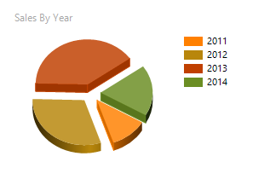

SELECT DISTINCT Year(OrderDate) as OrderYear

FROM Sales.SalesOrderHeader

ORDER BY 1

This Chart works because of the year for the sales.

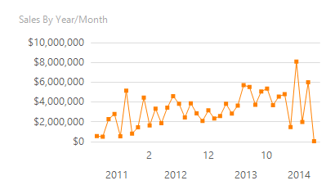

SELECT DISTINCT Year(OrderDate) as OrderYear

FROM Sales.SalesOrderHeader

ORDER BY 1

This Line with Markers Graph shows the sales of the year/ month.

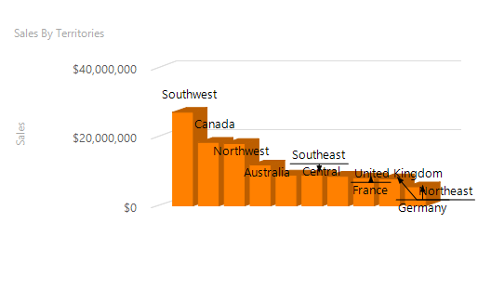

SELECT DISTINCT [Group] AS TerritoryGroup

FROM Sales.SalesTerritory

ORDER BY 1

The Parameter above is for the chart by territory that is being displayed.

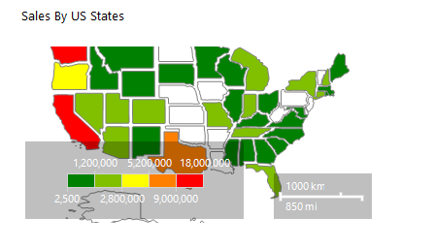

SELECT DISTINCT [Name] AS [State]

FROM Person.StateProvince

This parameter works because it is describing the total in each state.

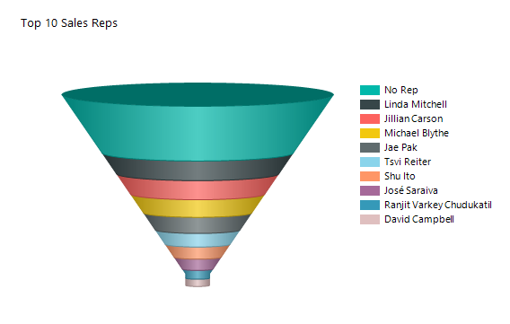

SELECT DISTINCT ISNULL (FirstName + ' ' + LastName, 'No Sales Rep') AS

SalesRep

FROM Sales.SalesOrderHeader A

LEFT JOIN Sales.vSalesPerson B ON A.SalesPersonID = B.BusinessEntityID

ORDER BY 1

This Funnel Chart shows the top 10 Sales Reps.